**What is software testing?**

**Ans:**software testing is a part of development process it is an activity to identify the defects in the software,objective of testing is to release a quality product.

**Software quality?**

Quality is defined as justification all the requirements of the customer in a product

Quality is not defined in the product it is defined in the customer mind

Bug free

Delivery on time

With in a budget

Meets requirement and expecting maintenance

**What is project vs product**

If the software application is developed for the specific customer based on requirements is called project

If the software application developed for the multiple customer based om market requirement then it is called product

**Why do you need testing**

Bug free

To increase the quality

To meets the customers requirements

Fixing the bugs after release is more expensive

**Error:-**any incorrect human action that produces in the system is called error

**Defect/bug:-**deviation from expected behaviour to actual behaviour is called defect

**Failure:-**the defect found by the end user is called failure

**why the software has bugs normally?**

Miscommunication or no communication

Software complexity(software properties that effects internal interactions)

Lack of knowledge in testers

Error in programming

Changes of requirements in last minute or in the middle of testing or deploy phase

**Software development life cycle {SDLC}**

Software development life cycle is used by software industry to design develop and test the software.

Requirement analysis

Design

Development

Testing

Deploy

Maintenance

**Water fall model**

This is old traditional model that we have develop the software first later on we have to test and deploy

**Advantages**

The product quality Is good

New requirements and changes are nit allowed so bugs will be less

Low investment

Preferred small projects

**Disadvantages**

Changes are not allowed in between the development or testing phase

Defect need more time to solve

Investment is high because the down time will be happen if the project is deployed or under maintenance

Testing has to be start after development only.

***The goal of a software tester is to find bugs, find them as early as possible, and make***

***sure they get fixed.***

**Why testing is necessery?**

Any level of testing cannot declare there is no defect in the product

Developer people assume that whatever they developed is right and they think its always work but in the real time scenario under take actual execution each level of software building including system level to check its actually working or not

The primary role Of software testing is not to demonstrate the correctness of

software product, but to expose hidden defects so that they can be fixed. Testing is done to protect the common users from any failure of system during usage.

Testing is a process Of demonstrating that errors are not present in the product

This approach is used in acceptance testing where if the application meets acceptance criteria, then it

must be accepted by the customer,

Testing gives number of detects present which indirectly gives a measurement of quality.

More number of defects Vindicate bad software and bad processes Of development,

The software doesn’t do something that the product specification says it should do.

The software does something that the product specification says it shouldn’t do.

The software does something that the product specification doesn’t mention.

**The number one cause for the bugs is specification**

**Next one id design**

**Next code**

**Test and release**

Bugs are caused for many reasons but the number one cause foe more bugs is specification

Specification is a largest bug producer its consistently changing or its not communicated to the entire developer team.

Planning the software is too important .if the planning was not done perfectly bugs will be created

The next largest bug producer is design

That means wrong design more bug

THE COST OF BUG

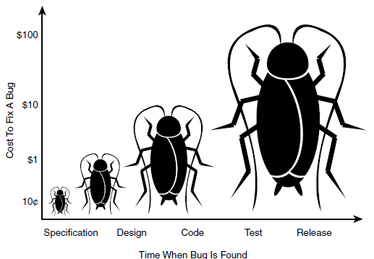

The bug costs are low when it is located in specification that gradually increases to design to code and code to test and release respectively.

If the costumer finds the bug in release lev that will more expensive it will loss more the laks

Example: if amazon flip-kart app is crashed for one hour due to the bug the operations will not happen that time then there in no server also there they will loss crores of money that one hour.

Or

In amazon a single product cost is 2000 but in the application level its showing 20 due to bug after release then lost will happen that time.

***The goal of a software tester is to find bugs, find them as early as possible, and make***

***sure they get fixed.***

***SOFTWARE TESTING :-***

To check the software is ok.

The goal of the software tester is to find bugs

This is process of the application to find out error in it

Verifying that software or application is bug free

***TYPES OF TESTING***

**MANUAL TESTING AUTOMATION TESTING**

Manual testing:- manual testing the software manually.without using automation tools.

Automation testing:-automation test is known as using automation tools,like if the tester write the script and used different software to test is called automation testing.

This test involves automation of manual process

Automation Testing is used to re-run the test scenarios that were performed manually, quickly, and

repeatedly.

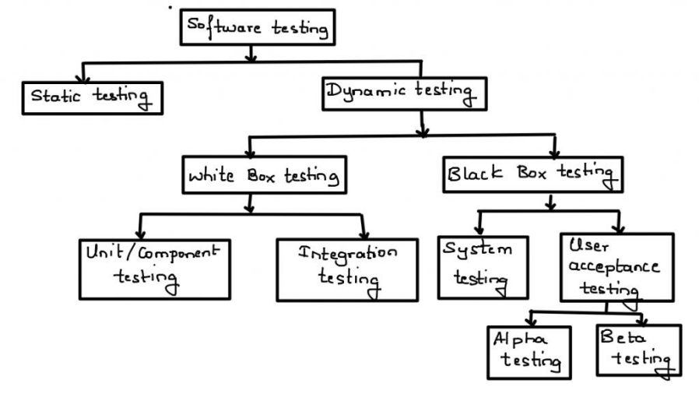

**Static testing techniques**

Analysis of a program program carried without executing the program.

Done during verification process I.e before development

As we know 80% errors occur in desiegn phase

Is code is tested in static testing ? “No” || the documentation is tested

Software development starts, continues, and ends with documentation

Early documentation → is used to define the software to be built

Later documentation covers → the software training, installation, and operation (user guides)..

Static = not while running

The primary goal of static testing is reduce defect by reducing defects in the

documentation from which the software is developed

**REVIEW:** It is a type of testing done before execution

Review is a process during which a work product or set of work products.to present managers,users,customers or other interested parties-for comment

**Walkthrough review**

It is not a formal process

It is led by the authors

Author guide the participants through the document according to his or her thought process

to achieve a common understanding and to gather feedback.

Useful for the people if they are not from the software discipline, who are not used to or

cannot easily understand software development process

**Inspection review**

It is a most formal review type

It is lead by the trained moderators

During inspection the documents are prepared and checked thoroughly by the reviewers before the meeting

**Informal review**

It is an unplanned and undocumented review

**Technical review**

Documented

Defined fault detection process

Includes peers and technical experts

No management participent

Static testing(before execution)

Review

Walkthrough (not Formal)

Inspection (formal finding fault)

Informal review (Unplanned and undocumented )

Technical Review (fault process)

**Dynamic testing techniques**

The process of evaluating a system or component based upon its behaviour during execution

**Black-box testing (functional)**

High level (main testing by tester)=system+UAT

1. system testing
2. Uat testing

**White box testing (non functional)**

Low level (programmer)=unit+integration

1. unit testing
2. Integration testing

Levels of testing

1. unit testing

In unit testing individual component of program tested.the purpose of this testing is that each module is working properly.if focuses on small unit of software design(done by the developer by using simple input and observing its sample output)

Ex:- In a program we are checking if loop method or function is working fine

1. integration testing

In integration testing individual units are combined and tested as group(Developer)

1. top down
2. Bottom up
3. Sandwich
4. Big-bang

Main purpose of integration testing is to check modules are communicating with each other as DFD data flow diagram which is specified in TDD(technical document diagram)

1. system testing :in this testing we can test whole application (complete/integrated sofware is tested)done by tester
2. Acceptance testing

A level of software testing in which software is tested for acceptance UAT done at client location where software is actually used

1. alpha testing:- done by tester in company in presence of customer
2. Beta testing :- done by customer to check the software is ok or not(safety requirement)